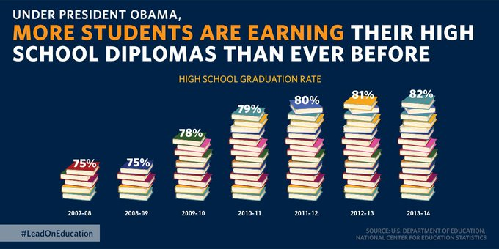

The figure above shows an example of a bad infographic (1). The information conveys the total amount of students who graduate and receive a diploma from 2007 to 2014. The intended audience is for decoders as it has been published on twitter for the general public. More specifically it is intended for voters and is trying to mislead them by inflating the % increase in high school graduation rates.

The visualization is misleading because the scale of data does not start from zero. A more accurate representation of the data would be to have a bar chart from 0-100%, this would show that the improvement over the years was only 7%. The poster suggests that the improvement is much larger due to the size of books, not the value assigned to it. The mechanism used here is obfuscating the data

Another misleading point can be found in the title, where one part is highlighted in a different colour. Quickly looking at this poster one might think it’s about earning of high school students rather than the pass rate. The mechanism used here is again obfuscating the data

**Citations**:

(1): https://twitter.com/ObamaWhiteHouse/status/677189256834609152